The FRASER McGREGOR  Memorial Golf Day  Friday 13th September 2019 | 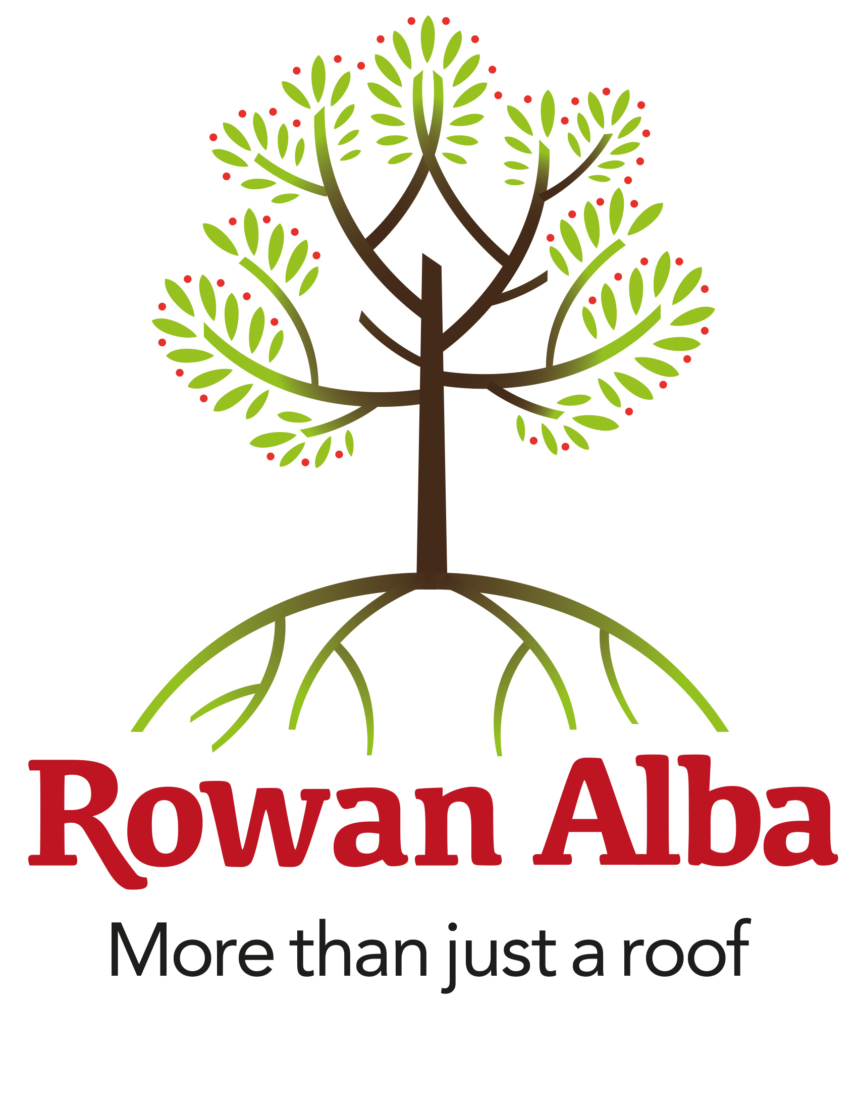  Booking Form  Bruntsfield Links Golfing Society

Charity Golf Tournament 2019

ENTER A TEAM  £400 | Each team has 4 people. First team gets a prize plus on the course prizes including ‘closest to the hole’. Please complete the following information:  Team Name:  Player Name Home Club Handicap CDH Number  Please state any specific dietary requirements:
SPONSOR A HOLE  £150 | When sponsoring, the company will get a mention in the programme of events and Rowan Alba social media plus website. | Tick this box to sponsor a hole
1ST PRIZE SPONSOR £500 | Any company can sponsor the 1st prize. The prize can be presented on the day and be mentioned in the programme and all associated publicity. | Tick this box to sponsor 1st Prize
2ND, 3RD TEAM AND RAFFLE PRIZES | Anything from hotel nights, meals, vouchers, food, days out at events, etc.  Prize description: | Tick this box if you would like to sponsor a raffle prize
Company Details  Please complete all details | Company:  ________________________________  Contact:  ________________________________  Phone:  _________________________________  Email:  _________________________________ | PAYMENT: Cheques to be made payable to Rowan Alba Ltd.  Alternatively, payment can be made by bank transfer to:  Account Name: Rowan Alba Ltd.  Bank: Bank of Scotland  Account number: 06070678  Sort Code: 801100  I would like to be invoiced for this booking [ ]

Please return completed forms to admin.assistant@rowanalba.org

