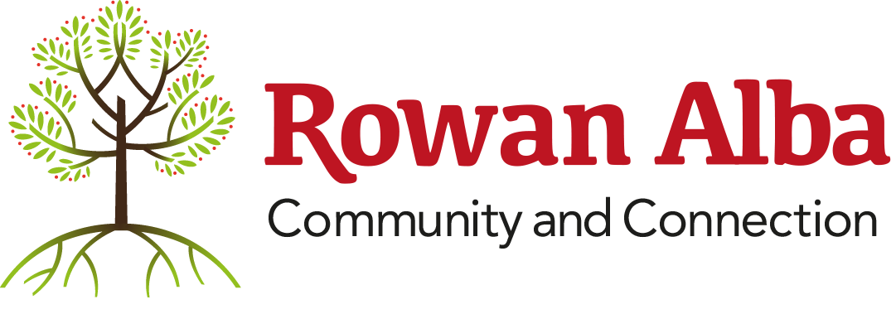

Application to join the Rowan Alba Board
Name: _______________________________________________
Address: _______________________________________________
Date of Birth: _______________________________________________
Current Employer: _______________________________________________
Date of Application: _______________________________________________

1. What Kind of Expertise Do You Consider You Will Bring to the Board?
Area of Expertise | n/a | Have some knowledge | Good current hands-on experience | Expert in this area
GOVERNANCE / ORGANISATIONAL RELATED
Ambassadorial experience | ☐ | ☐ | ☐ | ☐
Business development | ☐ | ☐ | ☐ | ☐
Communications | ☐ | ☐ | ☐ | ☐
Consultancy | ☐ | ☐ | ☐ | ☐
Customer / Membership Care | ☐ | ☐ | ☐ | ☐
Disability and discrimination | ☐ | ☐ | ☐ | ☐
Equal opportunities | ☐ | ☐ | ☐ | ☐
Financial, especially charity accounting | ☐ | ☐ | ☐ | ☐
Fundraising (all sources) | ☐ | ☐ | ☐ | ☐
Governance | ☐ | ☐ | ☐ | ☐
History of Sector: NGO/wider | ☐ | ☐ | ☐ | ☐
Human Resources | ☐ | ☐ | ☐ | ☐
Information Technology | ☐ | ☐ | ☐ | ☐
Legal (charity, company, employment, H&S) | ☐ | ☐ | ☐ | ☐
Management inc leadership, business, rules of engagement, encouraging democracy, volunteering | ☐ | ☐ | ☐ | ☐
Marketing (inc events) | ☐ | ☐ | ☐ | ☐
Media/PR | ☐ | ☐ | ☐ | ☐
Monitoring and evaluation | ☐ | ☐ | ☐ | ☐
Networks/Alliances/Partnerships | ☐ | ☐ | ☐ | ☐
Organisational development, inc change management | ☐ | ☐ | ☐ | ☐
Policy Implementation | ☐ | ☐ | ☐ | ☐
Political and parliamentary | ☐ | ☐ | ☐ | ☐
Property | ☐ | ☐ | ☐ | ☐
Research | ☐ | ☐ | ☐ | ☐
Strategic planning, strategic frameworks, systems | ☐ | ☐ | ☐ | ☐
Training provision | ☐ | ☐ | ☐ | ☐
Volunteer support | ☐ | ☐ | ☐ | ☐
Organisation-Specific Skills
1 | ☐ | ☐ | ☐ | ☐
2 | ☐ | ☐ | ☐ | ☐
3 | ☐ | ☐ | ☐ | ☐
4 | ☐ | ☐ | ☐ | ☐
5 | ☐ | ☐ | ☐ | ☐
Please use this space to elaborate on any specific skills you have which would make you a suitable candidate as a governing body member of the charity.

2. What other experience or skills do you feel you offer not listed above?
3. Are there any areas of the charity's work you have a particular interest in and/or would like to become more involved in?
4. What motivated you to apply to become a trustee of the charity?
5. How much time and commitment can you offer the role of a member of the Board of the charity?
6. Are you interested in taking up the position of an Office Bearer role e.g. Chair, Secretary?
Thank you for taking the time to complete this application. Please return it to:
Karen Barr, Chief Executive, Rowan Alba Ltd — kbarr@rowanalba.org

