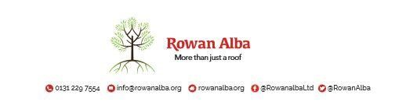

On-Call Rota
W/C Friday | On Call | Handover Time
03rd April | Emma | 5.00pm
10th April | Shannon | 5.00pm

This is a 5pm Handover, unless stated otherwise

* * * * *

 | CONTACT NUMBERS
DECLAN | 07503 663 504
SHANNON | 07876 650 052
EMMA | 07810 872 315
ANDREW | 07778 363 899

