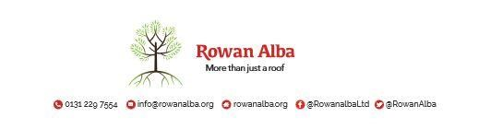

ON CALL ROTA

 | W/C Friday | On Call | Handover Time
 | 09th January | Declan | 5.00pm
 | 16th January | Ann | 5.00pm
 | 23rd January | Andrew | 5.00pm
 | 30th January | Tracey | 5.00pm
 | 06th February | Emma | 5.00pm
 | 13th February | Ann | 5.00pm
 | 20th February | Declan | 5.00pm
 | 27th February | Andrew | 5.00pm

This is a 5pm Handover, unless stated otherwise

* * * * *

 | CONTACT NUMBERS
ANN | 07503 668 012
DECLAN | 07503 663 504
TRACEY | 07715 082 427
EMMA | 07810 872 315
ANDREW | 07778 363 899

