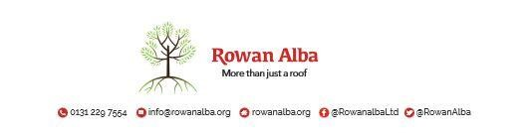

ON CALL ROTA

 | W/C Friday | On Call | Handover Time
 | 07th November 25 | Emma | 5.00pm
 | ^{14th November 25} | Declan | 5.00pm
 | 21st November 25 | Tracey | 5.00pm
 | 28th November 25 | Ann | 5.00pm
 | 05th December 25 | Andrew | 5.00pm
 | 12th December 25 | Declan | 5.00pm
 | 19th December 25 | Emma | 5.00pm
 | 26th December 25 | TBC | 5.00pm
 | 02nd January 26 | Tracey | 5.00pm

This is a 5pm Handover, unless stated otherwise

* * * * *

 | CONTACT NUMBERS
ANN | 07503 668 012
DECLAN | 07503 663 504
TRACEY | 07715 082 427
EMMA | 07810 872 315
ANDREW | 07778 363 899

