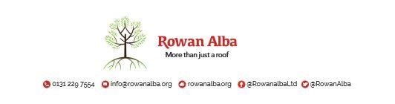

|  |  |  |  |
| --- | --- | --- | --- |
| ON CALL ROTA | | | |
|  | **W/C Friday** | **On Call** | **Handover Time** |
|  | **05th September 25** | **Lisa** | 5.00pm |
| **12th September 25** | **Tracey** | 5.00pm |
| **19th September 25** | **Sarah** | 5.00pm |
| **26th September 25** | **Declan** | 5.00pm |
| **03rd October 25** | **Andrew** | 5.00pm |
| **10th October 25** | **Emma** | 5.00pm |
| **17th October 25** | **Andrew** | 5.00pm |
| **24th October 25** | **Sarah** | 5.00pm |
| **31st October 25** | **Tracey** | 5.00pm |

**This is a 5pm Handover, unless stated otherwise**

* * * * *

|  |  |
| --- | --- |
|  | **CONTACT NUMBERS** |
| **ANN** | 07503 668 012 |
| **DECLAN** | 07503 663 504 |
| **SUSAN** | 07876 650 052 |
| **TRACEY** | 07715 082 427 |
| **EMMA** | 07810 872 315 |
| **ANDREW** | 07778 363 899 |
| **LISA** | 07796 616 528 |
| **SARAH** | 07385 500 613 |
| **DANNIELLE** | 07584 148 997 |