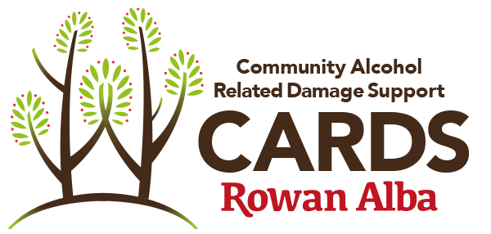

COMMUNITY ALCOHOL RELATED DAMAGE SERVICE VOLUNTEER AGREEMENT

Name of volunteer:

This agreement should be read alongside the Community Alcohol Related Damage Service Volunteer Role descriptor and the various Rowan Alba Policies, procedures and guidelines which are relevant to your post and are available on the website by visiting www.rowanalba.org/volunteers/volunteer-information or by request from your Volunteer Co-ordinator or CARDS Staff.

This agreement is designed to assure you of our appreciation of your volunteering and indicates our commitment to do the best we can to make your volunteering experience a positive and rewarding one.

Please note that this is a voluntary agreement only and does not constitute a contract of employment.

The following has been agreed between Rowan Alba Ltd. and the volunteer named above.

Main Responsibilities:

The main responsibility of the volunteer is to provide one-to-one sessions with CARDS clients in accordance with the Volunteer policies and procedures and role descriptor.
The volunteer agrees to follow all volunteer procedures, Rowan Alba policies and guidelines and to raise any concerns arising from carrying out their role with the CARDS Volunteer co-ordinator or CARDS staff. A copy of all Rowan Alba policies are available on request from the Rowan Alba Head Office.

The main volunteer policies/procedures include:

- Professional Boundaries Policy ● Volunteer Policy
- Disclosure of Information Policy ● Lone Worker Policy
- Health and Safety Policy ● Signing in/out procedure
- Adult Support and Protection Policy ● Case Notes Procedures
- Confidentiality Policy – Exert below

The volunteer agrees to carry out their role to the best of their ability within the aims and values of Volunteer Centre Edinburgh.

Time Commitment - Following initial induction and training, your agreed time commitment is 12 months.

Trial Period - All volunteer roles are subject to completion of satisfactory shadow sessions, initial training and ongoing support and supervision. For this role there will be an initial period where you will have supervision for a number of visits and thereafter you will work one to-one with CARDS service users. This is subject to review and requires consistent and comprehensive feedback from the volunteer to Rowan Alba Ltd.

Support & on-going training
Rowan Alba agrees to fully support you and will offer you regular support sessions, while you are volunteering with us. These may be in the form of group supervision, on the job supervision and one-to-one supervision with CARDS staff/senior volunteers. We will help you get the most from your volunteering, allow you to raise any concerns and help identify any relevant training or development opportunities. We encourage you to give us as much information and feedback as possible about your volunteer experience to help us to improve this ongoing support and to help you develop your role by giving you the opportunity to explore different volunteering responsibilities.

Confidentiality
You must not, either during or at any time after you stop volunteering with Rowan Alba, disclose any trade secrets or other confidential information relating to Rowan Alba or any of its activities including those in respect of which Rowan Alba owes an obligation of confidence to any third party.

“Confidential Information” means trade secrets and details of and information relating to employees, service users of Rowan Alba, matters of Health and Safety and any information, the release of which would damage Rowan Alba’s commercial interests, endanger staff or service users together with any information that is legally privileged. It also means any information which you are told is confidential, any information that is treated as confidential and any information in respect of which Rowan Alba has a duty of confidentiality to a third party including patients. Confidential Information also includes any and all information which Rowan Alba is not obliged to release under the Freedom of Information Act 2000 (the Act) and where you are uncertain whether a piece of information falls within the Act you will not disclose such information unless and until you have received advice from Rowan Alba’s CEO or Board of Directors.

In accepting to volunteer with us, you agree that during your time with Rowan Alba you will:
1. not without proper authority remove from Rowan Alba’s premises, any confidential information
2. if Rowan Alba requests, electronically delete or otherwise destroy all confidential information in your possession or under your control and destroy all other documents and tangible items (including back-ups and/or extracts of them) in your possession or under your control which contain or refer to any confidential information.

I agree with the conditions set out above.

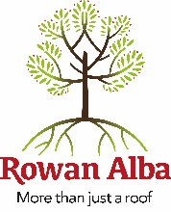
VOLUNTEER NAME

Signed…………………………………... (Volunteer) Date………………..

Signed…………………………………… (Volunteer Co-ordintator) Date………………..

