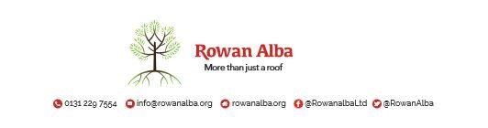

ON CALL ROTA
January 2022
 | W/C Friday | On Call | Handover Time
December 2021 | 31/12/2021 | Declan McKiernan | 5pm
January 2022 | 07/01/2022 | Demi McKay | 5pm
 | 14/01/2022 | Ann Logan | 5pm
 | 21/01/2022 | Emma Henderson | 5pm
 | 28/01/2022 | Tracey Stewart | 5pm

This is a 5pm Handover, unless stated otherwise

* * * * *

 | CONTACT NUMBERS
ANN | 07503 668 012
DECLAN | 07503 663 504
DEMI | 07384 254 745
TRACEY | 07715 082 427
EMMA | 07810 872 315

