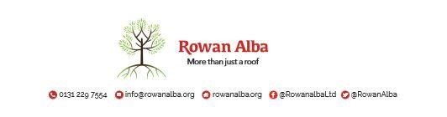

ON CALL ROTA
October 2021
 | W/C Friday | On Call | Handover Time
October 2021 | 01/10/2021 | Tracey Stewart | 5pm
 | 08/10/2021 | Declan McKiernan | 5pm
 | 15/10/2021 | Ann Logan | 5pm
 | 22/10/2021 | Demi McKay | 5pm
 | 29/10/2021 | Ann Logan | 5pm

This is a 5pm Handover, unless stated otherwise

* * * * *

 | CONTACT NUMBERS
ANN | 07503 668 012
DECLAN | 07503 663 504
DEMI | 07384 254 745
TRACEY | 07715 082 427

