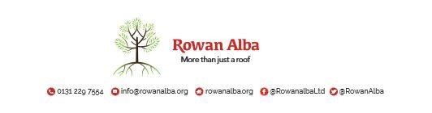

ON CALL ROTA
September 2021
 | W/C Friday | On Call | Handover Time
August 2021 | 27/08/2021 | Declan McKiernan | 5pm
September 2021 | 03/09/2021 | Tracey Stewart | 5pm
 | 10/09/2021 | Declan McKiernan | 5pm
 | 17/09/2021 | Demi McKay | 5pm
 | 24/09/2021 | Declan McKiernan | 5pm

This is a 5pm Handover, unless stated otherwise

* * * * *

 | CONTACT NUMBERS
ANN | 07503 668012
DECLAN | 07503 663504
DEMI | 07384 254 745
TRACEY | 07715 082 427

This version replaces any previous one Rowan Alba Head Office 28.05.2020

