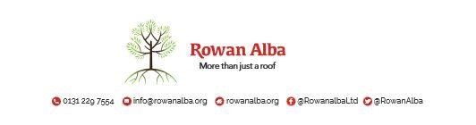

ON CALL ROTA
August 2021
 | W/C Friday | On Call | Handover Time
July 2021 | 30/07/2021 | Declan McKiernan | 5pm
August 2021 | 06/08/2021 | Ann Logan | 5pm
 | 13/08/2021 | Tracey Stewart | 5pm
 | 20/08/2021 | Demi McKay | 5pm
 | 27/08/2021 | Declan McKiernan | 5pm

This is a 5pm Handover, unless stated otherwise

* * * * *

 | CONTACT NUMBERS
ANN | 07525 831 390
DECLAN | 07525 831 389
DEMI | 07384 254 745
TRACEY | 07715 082 427

This version replaces any previous one Rowan Alba Head Office 28.05.2020

