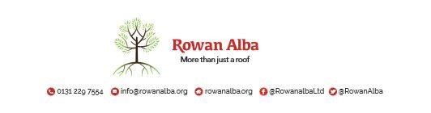

ON CALL ROTA
June 2021
 | W/C Friday | On Call | Handover Time
June 2021 | 28/05/21 | Declan | 5pm
 | 04/06/21 | Ann | 5pm
 | 11/06/21 | Demi | 5pm
 | 18/06/21 | Tracey | 5pm
 | 25/06/21 | Ann | 5pm

This is a 5pm Handover, unless stated otherwise

* * * * *

 | CONTACT NUMBERS
ANN | 07525 831 390
DECLAN | 07525 831 389
DEMI | 07384 254 745
TRACEY | 07715 082 427

This version replaces any previous one Rowan Alba Head Office 28.05.2020

