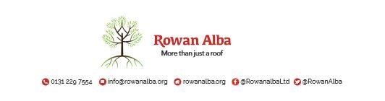

ON CALL ROTA
April 2021
April 2021 | W/C Friday | On Call | Handover Time
 | 02/04/21 | Demi | 5pm
 | 09/04/21 | Tracey | 5pm
 | 16/04/21 | Ann | 5pm
 | 23/04/21 | Declan | 5pm
 | 30/04/21 | Demi | 5pm

This is a 5pm Handover, unless stated otherwise

* * * * *

 | CONTACT NUMBERS
ANN | 07525 831 390
DECLAN | 07525 831 389
DEMI | 07384 254 745
TRACEY | 07715 082 427

This version replaces any previous one Rowan Alba Head Office 28.05.2020

