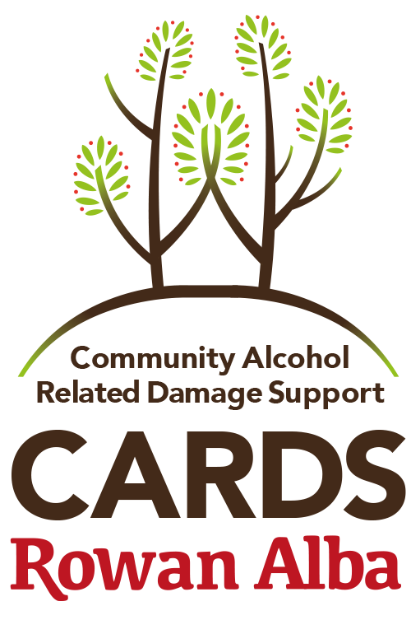

CARDS Volunteer Role Description

Rowan Alba Limited
a Company Limited by Guarantee 289744 with Charitable Status (Charity No. SC036775)
Head Office, 89-95 Fountainbridge, EDINBURGH, EH3 9PU

CARDS work with individuals who have a problematic, long term history of alcohol use in the local community who are currently receiving little or no support in terms of their mental, physical and emotional wellbeing. The basic idea of the service is to identify the hard to reach vulnerable adults in Edinburgh through a community referral system and referral direct from the NHS Integrated ARBD Care Pathway. We offer the support of a relationship with one of our volunteers and this in itself becomes the vehicle to positive health and social outcomes.

What a CARDS Volunteer is expected to
- Be interested, curious and respectful enough to listen to someone irrespective of your own thoughts on their lifestyle and choices
- Be happy to share your reflections on how this new relationships shapes your thoughts and feelings about yourself, the individual and the service we provide
- Be able to look after your own well being. Understand and recognize your own limitations in respect of the time, energy and commitment you have to give the service
- Maintain safe boundaries and recognize when boundaries need to be re-assessed with support
- Be able and willing to ask for help and advice and share experiences and knowledge with peers in one-to-one and group supervision situations.
- Have an interest in working with people and being part of our team whilst understanding that your role is to work alone in the community and report back in to us
- Have a positive attitude, be reliable and most importantly be able to give and receive feedback.
- Work within the framework of Rowan Alba’s policies and procedures and in line with the ethos of delivering person centred support planning in a non judgemental fashion
- Be capable of accurately recording interactions with clients and emailing in to the service
- Provide signposting to appropriate services, if that is what the person would like
- To periodically be involved in evaluating the services effectiveness and delivery
- To provide updates, visit notes and feedback as required, especially with regard to health and safety / risk assessment related issues
- Have flexibility with suggestions for ways forward, be supportive of ideas and thoughts and negotiate a different path when deemed necessary

What a CARDS Volunteer will not be expected to :

- Be the only contact that person has. The service is the main point of contact
- Have any control over a client’s social habits, lifestyle choices and decisions
- Stop a person from drinking or stop them relapsing
- Lend or borrow money or exchange gifts with the client
- Be a saviour or evangelist
- Always be able to have a rational conversation with the individual as there will be times this might not be possible.
- Remove anyone from their current living condition no matter how chaotic or dangerous
- Step outwith their role in representing the CARDS service, values and ethos
- Pass on any information about the individual to anyone outside Rowan Alba. This includes ANYONE - Partners, friends, work colleagues or people introduced to them by the individual.
- Be in the relationship for ever. The service IS open ended but new volunteers replace you when you move on. This is explained from the start
- Be anything other than yourself with guidance and support to remain professional.

Benefits / Training and Support :

- The initial induction is normally one days training with six online modules. The learning comes only from the reflection time you put in to your practice. We will provide you with time slots to to Zoom, Skype or Facetime with our staff who have over 20 years experience to progress your learning and development.
- Regular reflective practice supervisions from a clinical psychologist/psychotherapist who works with individuals and groups effected by homelessness. (This will return when restrictions are lifted and groups are allowed)
- Supervision is mandatory and non negotiable.
- Get valuable experience working with this client group and be part of a progressive organisation with a wider aim of homelessness prevention.
- Be an active member contributing to the NHS Lothian Alcohol related Brain Damage care pathway and have access to practical experience in working with all related partners.
- Full access to Rowan Alba training package which includes reduced cost or free SVQ qualifications, ILM Coaching certificates
- Training on ARBD, person centred philosophy, coaching practice, boundaries, lone working, harm reduction, mental health and any other training deemed relevant to your work.
- We have a pathway to employment where those looking to work in the sector achieve the experience necessary to meet industry wide person specifications for the job roles within our organization and across this industry.
- We welcome individuals who have their own lived experience with problematic alcohol use and support you to use this experience in the support of another safely.

Health and Safety

- Rowan Alba take the Health and Safety of both service user and volunteer extremely seriously. Following on from referral information obtained, project staff will carry out a comprehensive risk assessment of working with the service user from a perspective of ensuring the person referred meets the broad service provision criteria and to minimise any risks to volunteers and project staff. You as the volunteer are responsible for communicating any new risks so we can keep this role safe for all.

Time Commitment:
A minimum regular commitment of two hours per week for 6 months is required. The volunteer can terminate the arrangement at any time.

Criminal Convictions Checks: Rowan Alba Ltd carry out full disclosure and PVG checks for all employees and volunteers.

What to do next: For an Application Pack including job description and person specification, please visit our website at www.rowanalba.org or contact the CARDS team on 0131 229 7554 or cards@rowanalba.org.

