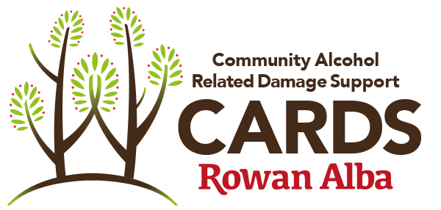
CARDS VOLUNTEER PERSON SPECIFICATION

SKILL/QUALIFICATION | ESSENTIAL | DESIRABLE | DEMONSTRATED BY
Ability to work as part of a team and lone work in a community setting. | ü |  | Application
Ability to draw on your own lived experience of recovery from problematic alcohol use in the support of others. | ü  (peer only) |  | Interview
Be a confident communicator with good listening skills. | ü |  | Application/Interview
Have an interest in the client group. (Socially isolated individuals) | ü |  | Application
Be a motivated person with positive attitude, who is reliable and conscientious. | ü |  | Application/Interview
Be capable to accurately recording interactions with clients. | ü |  | Application
Be interested in people and comfortable making conversation. | ü |  | Application/Interview
A level of previous experience, training or qualification in a coaching based field. |  | ü | Application/Certificate
Be open to feedback on your performance | ü |  | Ongoing learning

