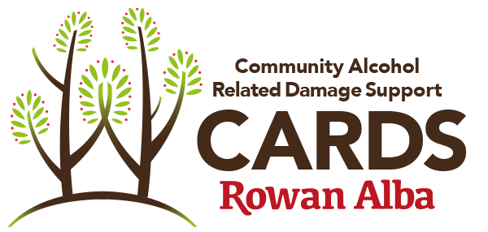

Photo consent form

Please read and ensure you are fully aware of this document before you sign, should you choose to. To comply with the UK Data Protection Act, your permission is needed before we are able to use an image of you. No image will be used without your permission. It is likely that these images may be included in our printed publications (leaflets); adverts; audiovisual and electronic materials (website/twitter/Facebook); media work; display materials; and any other media we may use in the future
If it is given, you may remove your permission at any time by contacting us using the contact information at the bottom of this document.
Your details:
First Name |  | Family Name
Address
 |  | Postcode
Telephone
Email

Please state here if there are any ways in which you do NOT want us to use photo(s) of you:

Signed  or type if emailed |  | Date

Data protection statement
Other than as specified above, the information that you give us here will only be used to contact you about these photo(s). We will not include personal details or names, personal e-mail postal addresses, or telephone numbers on video, on our website, or in other printed publications. We will not pass the details recorded on this form on to any other organisation without your permission.
Please return completed forms to:
Rowan Alba 89-95 Fountainbridge, Edinburgh EH3 9PU. Tel: 0131 229 7554. info@rowanalba.org.
A Company Limited by Guarantee 289744 with Charitable Status (Charity No. SCO36775)

