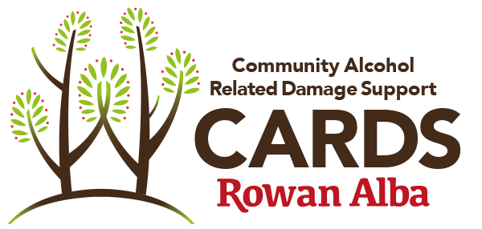

CARDS VOLUNTEER INTERVIEW RECORD

This form is intended as a guide when interviewing volunteer applicants.

The interviewer completes this form during or straight after the interview.

Applicant:…………….……………Interviewer(s):……………………………..

Scheme/Project: Date of Interview:

A. Find out about the volunteer’s interest and abilities and motivations
1. What interests you in volunteering with Rowan Alba CARDS service? What are you looking for from this placement? (if information provided in the application form is unsatisfactory)

2. What will make you feel like your volunteering has been positive or successful for you and the clients? What can we do to help you achieve this?

B. Discuss the volunteer position available
Refer to the Volunteer CARDS Role Descriptor and explain the overall aim of the voluntary position, the tasks and responsibilities involved, and the skills required
3. How do you feel about these volunteer tasks? Are there any areas of concern?

3b. The CARDS service will involve visiting clients in a community setting and in their own home. How do you feel about doing this, given the potential for clients to have had a drink before you arrive?

3c. The Volunteer role involves close contact with clients whose personal circumstances may be chaotic and traumatic which can generate intense emotions and trigger memories which may be unpleasant. How do you take care of your own well-being and what supports do you have in place?

PEER ONLY - 3d. What is your recovery and how would you use it to the benefit of the client?

4.Commitment and reliability are very important to the service. How do you feel about giving a regular time commitment? Why do you think this is important?

5. How would you go about establishing a good relationship with someone you have never met before and making them feel comfortable and able to share their life story and issues with you?

6. Within Rowan Alba, we have established policies and procedures to protect our service users, staff and volunteers, e.g. gifts policy, confidentiality, code of conduct, etc. Have you had to deal with similar policies and procedures in the past? How did you find this?

Discuss our requirements and any other information
Refer to the Volunteer CARDS Role Descriptor and explain the time commitment, training and support, benefits of volunteering and details of reference and criminal conviction checks.

7. You will receive regular support from staff and will be required to actively participate in support and supervision based on the principles of reflective practice. Are you able to commit to this process?

Yes No

INFORMATION TO BE GIVEN AT THIS STAGE REGARDING THE PVG Scheme

Note to Interviewer : Check with Interviwee if reference information on application form is correct and inform them of the next stages. Direct them to the induction documents on the website for pre course reading?

Signed by Interviewer(s): ..................................................

Date:

